**COVID-19 Numbers in relation to both latitude and GDP**

Analyzing the effects: infections, infections per population, and deaths of COVID-19 on a global scale seeing what regions/countries have been affected more and less severely, see if the countries’ latitude and GDP has a relationship to the COVID infection numbers, and make conclusions to why or why not these correlations exist.

**Hypothesis:** Latitude and COVID have a positive relationship due to environmental factors such as weather, as a location gets further away from the equator, there will be more infections and deaths due to people being inside more often, similar to the relationship with influenza. GDP of a location and COVID effects have a negative relationship: as a country is more wealthy, they will be able to better handle the overall effects of the pandemic, particularly when it comes to deaths and deaths per cases.

**Does latitude positively or negatively affect the COVID-19 infection rate/deaths?**

We have hypothesized that latitude could affect COVID effects due to countries having different environmental, cultural, and weather considerations. As you can see from the above boxplots above the infections and deaths from COVD-19 are influenced by significant outliers that will affect any relationship overall, this will have to be taken into consideration for any analysis. Since the primary factor we are investigating is distance from the equator, we have taken the absolute value of the countries latitude in order to better represent its location in visual form. First we will look at Cases vs. Degrees from the equator:

As you can see in the visualizations above this number is significantly influenced by 3 significant outliers and dropping them from the dataset significantly affects the overall correlation. There is a slight positive relationship between number of overall cases and the distance from the equator however the correlation is weak to none overall. Next we will look at the deaths per 100,000 people vs. distance from the equator:

Again there is a slight positive relationship between deaths per 100,000 people in the countries population and the distance from the equator, this time with a stronger correlation of .02269 but still weak overall but analyzing on a global scale, this is the strongest correlation that was found. The possible reasons that there was a stronger correlation could be due to colder temperatures and potentially higher population densities more located in cities as the latitudes increase in absolute value. Eliminating extreme outliers in this case did not have the same effect as noted on the previous example, this is primarily due to having less significant outliers overall. Since, the highest correlation found between COVID effect numbers and distance from the equator is this weak, it appears that COVID-19 infections/deaths are not significantly related to a countries location on the earth and that other factors are to blame for higher and lower impacts.

**Does latitude play a more significant role when we look deeper into countries of similar population size?**

**Alternate: Keeping the population size constant, if latitude changes then COVID-19 cases and deaths will be positively or negatively affected.**

**Null: Keeping population size constant, if latitude changes then COVID-19 cases and deaths will not be affected.**

On the larger scale, we found that there was almost no correlation between COVID numbers and distance from the equator and surmised that there must be other factors at play. Controlling for one of those factors, population size, we took a deeper look to see if the correlations changed when looking only at countries with similar population sizes. We did this by breaking down our countries into approximately equal groups by population, and the results were quite interesting! Some of the ranges had negative correlation, some had minimal correlation, and others had low but statistically significant correlation. The highest correlations for total cases came from the population range of 110k to 799k and 11.5m-18.9m:

However, there were also ranges with negative or minimal correlation:

This pattern continued when comparing with the other statistics for death, with some higher and some lower correlations:

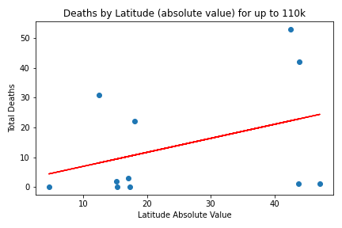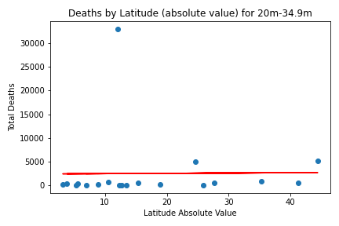

And for mortality rate (death per 1000 cases):

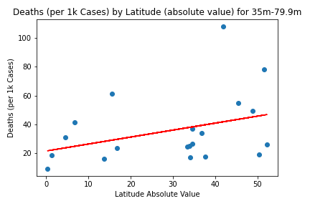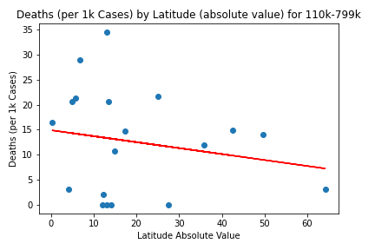

We also tracked the correlation coefficient and r squared value for each comparison at all of the population ranges to see if there was a noticeable trend. There was no overarching trend for there to be stronger or weaker correlation at higher or lower populations, which we had thought there might be.

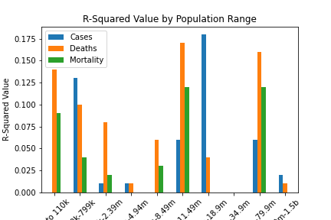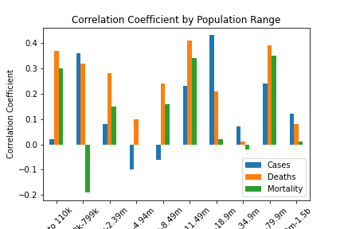

None of the r-squared values surpassed 1.75, and our highest correlation coefficient was .43, so we concluded that there was not a strong relationship between latitude and COVID, even when controlling for similar population sizes.

**Mortality by Population:**

One slight trend that we did notice when looking at the smaller popular was the relationship between population size and mortality rate, which seems to increase slightly at higher population sizes.

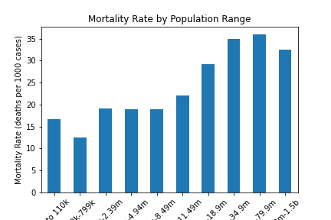

**What is the relationship between COVID-19 effects for a population and a country’s GDP?**

Since there was little relationship between a country’s distance from the equator and the effects from COVID, maybe there is more of a relationship between a country’s GDP and the overall effects. We hypothesized that there could be a negative relationship due to, theoretically, that a more wealthy country would potentially have more advanced healthcare and would have a better response to the virus. There was a thought specifically that there would be a higher recovery rate and less deaths per cases with a wealthier nation. Similar to when looking at COVID effects and latitude, with GDPs there were also significant outliers. First we look at the Deaths vs. GDP:

Due to some significant outliers we also look at some of the top end GDPs removed:

As we hypothesized, there is a slight negative relationship between GDP and deaths, however, the r-value of this regression is 0.1863 giving limited to no relationship overall. Although there is very limited relationship in the regression, when we looked at the binned GDPs versus deaths per 1,000 cases, it is notable that the numbers are quite flat until reaching the very high GDPs, where the deaths are notably lower. As seen below, so there still could be some relationship just not seen in a straightforward linear regression.

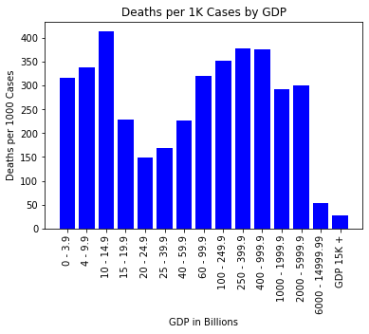

**Conclusion**

Although we did see the hypothesized slopes when graphing COVID-19 effects versus both latitude/distance from the equator and with GDP, the overall relationships were very weak. There were some stronger relationships when analyzing particular population size versus latitude, but the maximum correlation still came in at 0.43, overall, showing limited relationship at best. So from our analysis, distance from the equator and its associated factors, along with GDP of a particular country and its associations, do not have a particularly strong effect of a locations ability to deal with the effects of COVID-19. Whether a country is on the equator or toward the North or South pole has limited effect. Likewise, the relative poverty or wealth of a country does not lead to specific results either. Obviously, there are various factors that go to a country’s ability to respond to pandemic but it appears that it has more to due with healthcare and government infrastructures than anything having to do with location or wealth.